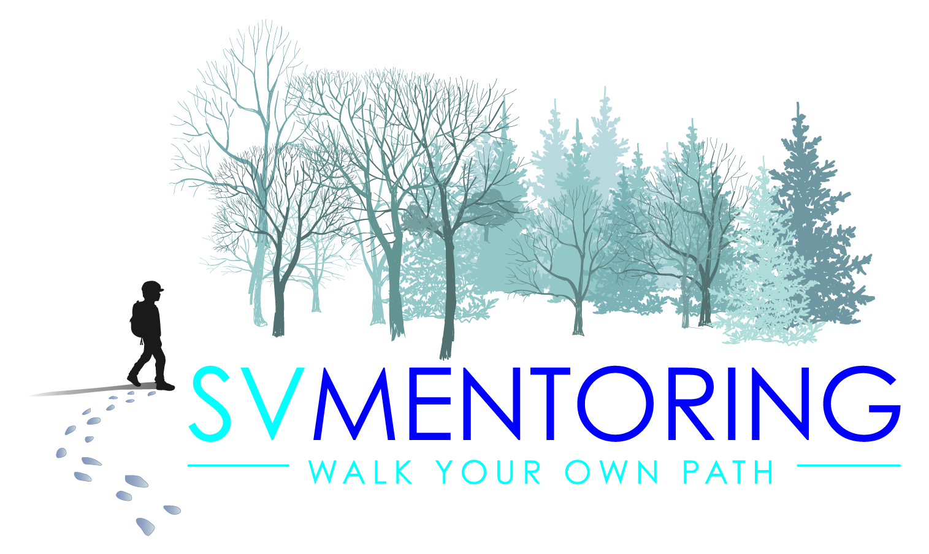
Application Form 2024

Position applying for: Learning Mentor
I confirm that I have the right to work in the UK:
I confirm that I have a valid in date enhanced DBS:
Yes:
No:
I would like to apply for one through SV Mentoring:

Personal Details
This Information will NOT be used for short-listing.
Title:
Name:
First:
Last:
Email:
Phone Number (mobile preferred):

Employment History
This information will be used for short-listing
Please attach relevant CV with this application
Job Title of Current or Most Recent job:

Do you have relevant work experience?
No :
Yes:
Do you have relevant personal experience of supporting young people with challenging behaviours and additional needs?
No:
Yes:
Do you have relevant qualifications or training?
No:
No but in progress:
Yes:

References
Please provide two references, one from your current or most recent employer
Name:
Position:
E-mail:
Contact number:
Address:

Name:
Position:
E-mail:
Contact number:
Address:

Almost done! You can now tell us why you think you are the right person for the job!:

Where did you see this post advertised?

Date:
Signature:

Thank you!
All job offers are subject to the receipt of satisfactory references and an enhanced DBS check.

www.svmentoring.co.uk

